Nama : Halomoan Nababan
Npm : 219510078
Kelas : 7TIB

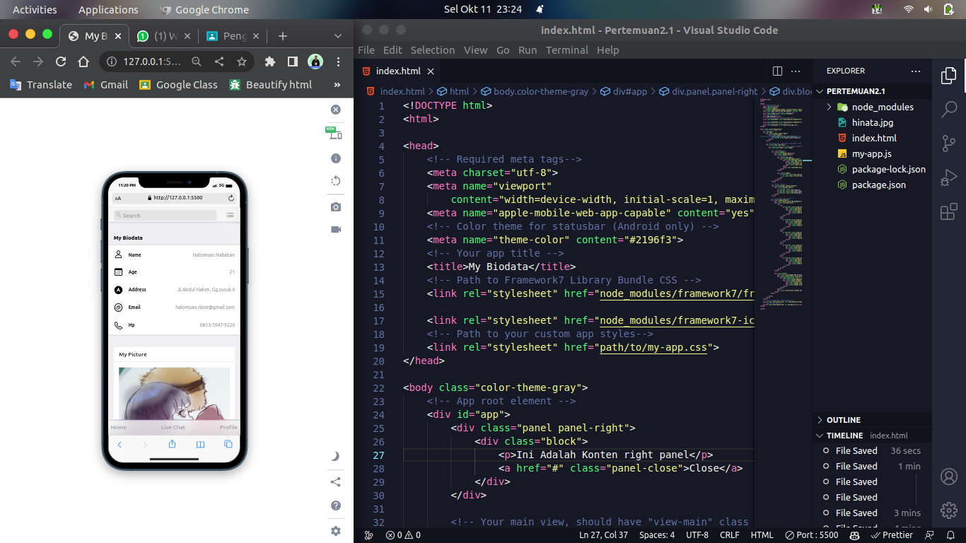

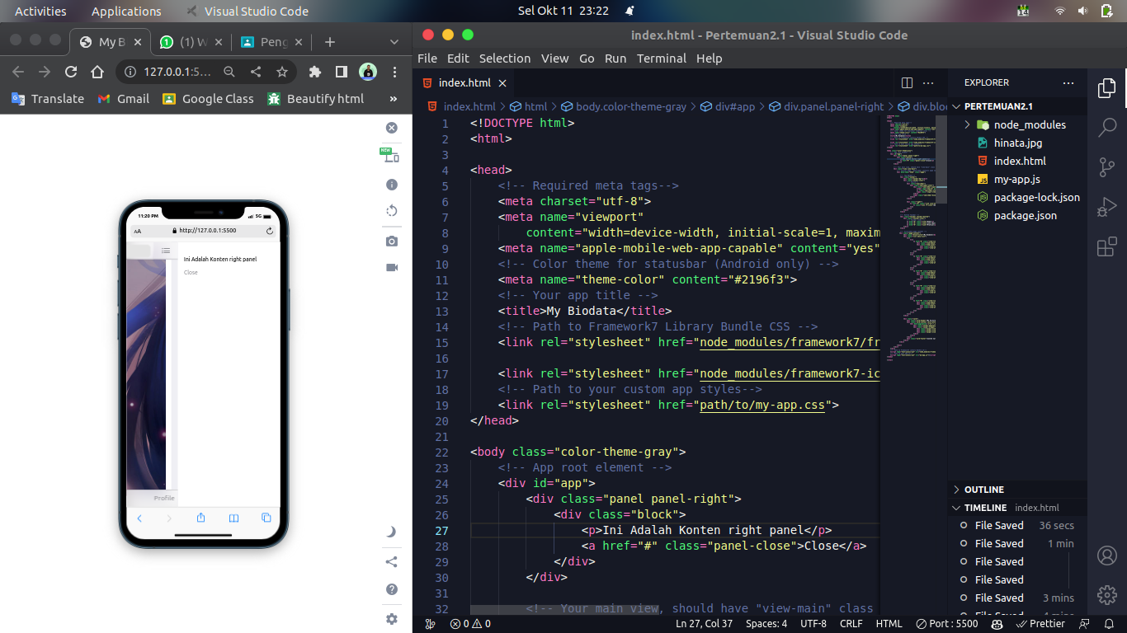
<!DOCTYPE html>
<html>

<head>
<!-- Required meta tags-->
<meta charset="utf-8">
<meta name="viewport"
content="width=device-width, initial-scale=1, maximum-scale=1, minimum-scale=1, user-scalable=no, viewport-fit=cover">
<meta name="apple-mobile-web-app-capable" content="yes">
<!-- Color theme for statusbar (Android only) -->
<meta name="theme-color" content="#2196f3">
<!-- Your app title -->
<title>My Biodata</title>
<!-- Path to Framework7 Library Bundle CSS -->
<link rel="stylesheet" href="node_modules/framework7/framework7-bundle.min.css">

<link rel="stylesheet" href="node_modules/framework7-icons/css/framework7-icons.css">
<!-- Path to your custom app styles-->
<link rel="stylesheet" href="path/to/my-app.css">
</head>

<body class="color-theme-gray">
<!-- App root element -->
<div id="app">
<div class="panel panel-right">
<div class="block">
<p>Ini Adalah Konten right panel</p>
<a href="#" class="panel-close">Close</a>
</div>
</div>

<!-- Your main view, should have "view-main" class -->
<div class="view view-main">
<!-- Initial Page, "data-name" contains page name -->
<div data-name="home" class="page">

<!-- Top Navbar-->
<div class="navbar">
<div class="navbar-bg"></div>
<div class="navbar-inner">
<!-- Search-->
<div class="searchbar">
<div class="searchbar-inner">
<div class="searchbar-input-wrap">
<input type="search" placeholder="Search">
<i class="searchbar-icon"></i>
<span class="input-clear-button"></span>
</div>
<span class="searchbar-disable-button">Cancel</span>
</div>
</div>

<div class="right">
<a href="#" class="link icon-only panel-open" data-panel="right">
<i class="icon f7-icons">menu</i>
</a>
</div>
</div>
</div>

<!-- Bottom Toolbar -->
<div class="toolbar toolbar-bottom">
<div class="toolbar-inner">
<!-- Toolbar links -->
<a href="#" class="link">Home</a>
<a href="#" class="link">Live Chat</a>
<a href="#" class="link">Profile</a>
</div>
</div>

<!-- Scrollable page content -->
<div class="page-content">
<div class="block-title">My Biodata</div>
<div class="list menu-list">
<ul>
<li>
<a href="#" class="item-link item-content">
<div class="item-media"><i class="icon f7-icons">person</i></div>
<div class="item-inner">
<div class="item-title">Name</div>
<div class="item-after">Halomoan Nababan</div>
</div>
</a>
</li>
<li>
<a href="#" class="item-link item-content">
<div class="item-media"><i class="icon f7-icons">calendar</i></div>
<div class="item-inner">
<div class="item-title">Age</div>
<div class="item-after">21</div>
</div>
</a>
</li>
<li>
<a href="#" class="item-link item-content">
<div class="item-media"><i class="icon f7-icons">location_circle_fill</i></div>
<div class="item-inner">
<div class="item-title">Address</div>
<div class="item-after">Jl.Abdul Hakim, Gg.susuk II</div>
</div>
</a>
</li>
<li>
<a href="#" class="item-link item-content">
<div class="item-media"><i class="icon f7-icons">at_circle</i></div>
<div class="item-inner">
<div class="item-title">Email</div>
<div class="item-after">halomoan.nbnz@gmail.com</div>
</div>
</a>
</li>
<li>
<a href="#" class="item-link item-content">
<div class="item-media"><i class="icon f7-icons">phone</i></div>
<div class="item-inner">
<div class="item-title">Hp</div>
<div class="item-after">0813-7647-9226</div>
</div>
</a>
</li>
</ul>
</div>

<div class="card">
<div class="card-header">My Picture</div>
<div class="card-content card-content-padding">
<div data-pagination='{"el":".swipper-pagination" }' data-space-between="50" class="swiper swiper-init">
<div class="swiper-pagination"></div>
<div class="swiper-wrapper">
<div class="swiper-slide" style="min-width: 50px"><img src="hinata.jpg" alt=""></div>
<div class="swiper-slide"><img src="hinata.jpg" alt=""></div>
<div class="swiper-slide"><img src="hinata.jpg" alt=""></div>
</div>
</div>
</div>
<div class="card-footer">Contoh Card Konten</div>
</div>
</div>
</div>
</div>
</div>
<!-- Path to Framework7 Library Bundle JS-->
<script type="text/javascript" src="node_modules/framework7/framework7-bundle.min.js"></script>
<!-- Path to your app js-->
<script type="text/javascript" src="my-app.js"></script>
</body>

</html>

